**HP COLLEGE OF EDUCATION (HPCE)**

**Airport Road Totu Shimla-171011**

**PROSPECTUS-CUM-INFORMATION BROCHURE**

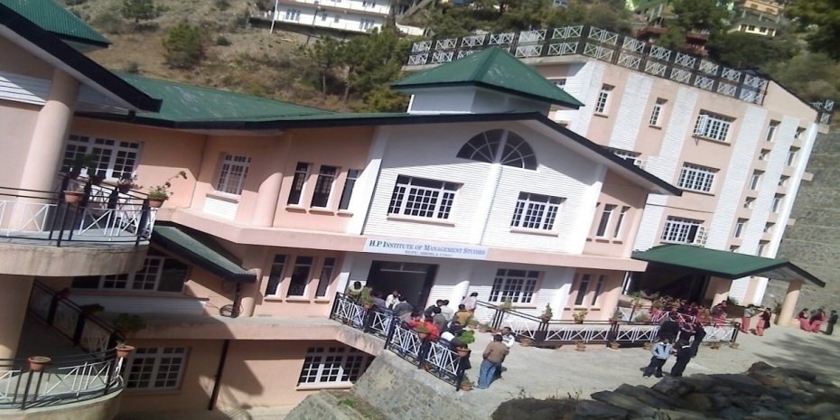

**B.Ed. (Session: 2025-2027)**

**Under the aegis of Krishna Educational Society (Regd.)**

**Approved by National Council for Teacher Education (NCTE)**

**Recognized by Govt. of Himachal Pradesh**

**&**

**Affiliated to H.P. University**

**Email:** [**krishnaeducationalsociety2007@gmail.com**](mailto:krishnaeducationalsociety2007@gmail.com)

**Website:** [**www.hpceducation.org**](http://www.hpceducation.org)

**ACTIVITIES AT A GLANCE**

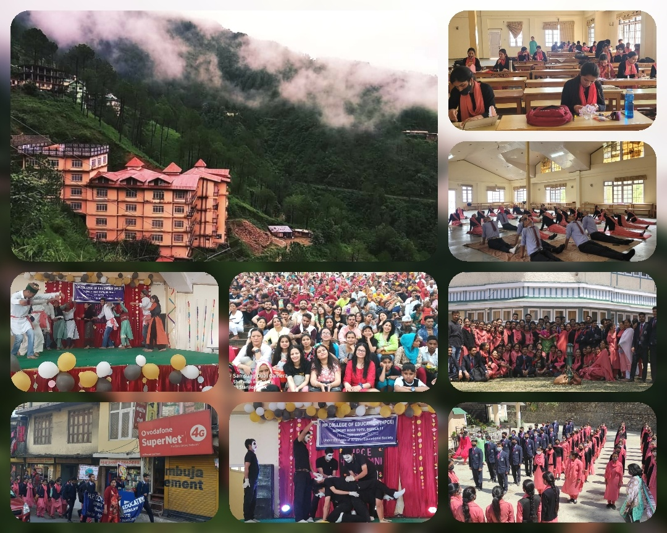



**Message**

On behalf of the **HP College of Education (HPCE),** I extend a warm and cordial welcome to all aspirants for Teacher education to this beautiful and charming valley which is being brought up in the lap of nature. Teachers play a very important role in a student’s life. It’s a teacher who guides a student through his or her career. So it is very significant to be adequately equipped with resources that will create the teacher an ideal role model to the students. To achieve this**, B.ED courses** is introduced by **Krishna Educational Society (KES)** which will teach a person about teaching and the different aspects associated with it.

Since Inception, **HP College of Education (HPCE)** strive its best with the vision of producing knowledgeable teachers for a global society. Today as we witness the drastic changes in the field of education, our teacher training programme goes beyond pedagogy. Our college realizes the need for competent and committed teachers for a society and with that objective we strive forward.

College is a platform where the students prepare themselves to face the world and **HP College of Education** has striven to mould the personalities of students in such a way that they can face the perplexing, complex situations and challenges of life with confidence. We provide a plethora of activities for the judicious all-round development of youthful energies, properly channelized towards creativity and self-actualization. Further, we are devoted to the task of inculcating in the young minds; values which will lead to the refinement of the entire personae, thereby, making them stand apart as **“A meteorite sparkles in the galaxy of human race”.**  
 With the explosion of knowledge and globalization of education across social, cultural and geographical boundaries, we provide our students with unique multi-cultural programmes. This on one hand helps our students to know about the socio-economic, cultural and educational scenario and on the other hand, takes our college and students to national platform. Thus, our students have an edge over others as they are well equipped to face the global challenges.

To conclude, I on behalf of all the members of the Management, Faculty and Administrative staff of the **HPCE** assure society in general, students and parents in particular that no stone shall be left unturned in grooming the students of **HPCE**.

At the end I wish all of you a bright future as members of **Krishna Educational Society** and beyond.

**Krishna Rawat**

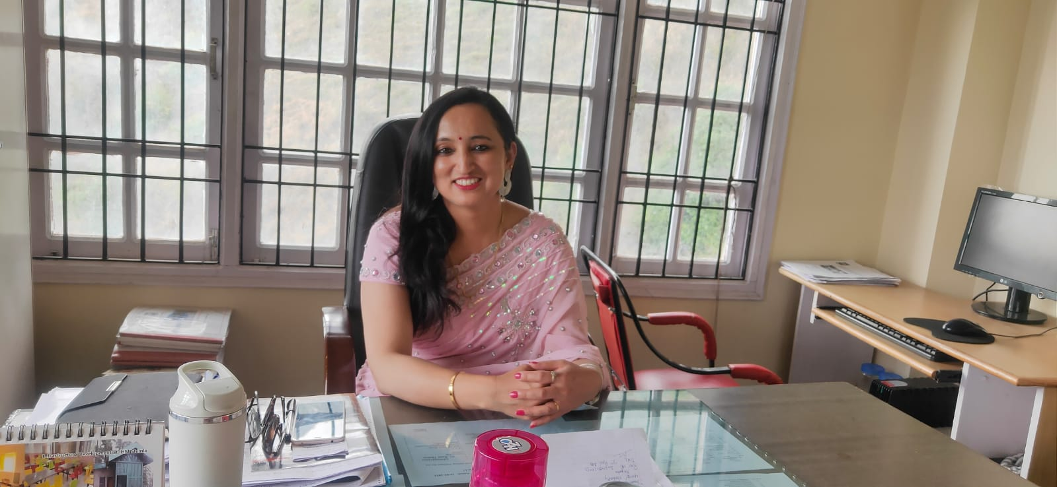

**Principal’s Desk**

“We are passionate about teaching and learning and inspiring our students to believe in themselves and be proud of whom they are and their achievements.”

As men & women, we all owe a duty towards the society and to all that comprises good education. Education is a means to the fulfillment of that duty. Education is a companion, whom no misfortune can depress, no crime destroys, no enemy alienates, no despotism enslave. It is a mission to inculcate good values in the students.

At home education is a friend, in solitude a solace, and in society a light that dispels darkness and brightens humanity to all eternity. A teacher plays a very significant role in providing good education. A teacher of strong moral character and well aware of modern techniques of teaching skills and capable of using them to his students is able to influence the personality and character of his students. A successful teacher help the students to learn resilience and build self confidence thus, the process of education revolves around the teacher and taught in the society.

H P College of Education is one of the leading Institutions of the region situated at Airport Road Totu, Shimla-11. College is fully equipped with infrastructure providing all facilities to the trainees and staff. We have an efficient and committed faculty team, enriched infrastructural facility, well-furnished class-rooms, common hall, well equipped library and laboratories for various subjects. We also provide buses to the trainees and staff. Our well experienced and hard working faculty makes this college an Institution with a difference among the other Institutions of teacher education in the state of Himachal Pradesh.

I am confident that this Institution will help in developing personality of quality teachers which in turn will prove an asset to the society and to the nation as well.

**Dr. Ranu Thakur**

**Introduction**

**SHIMLA**, a hill station, located on a high ridge at an elevation of 2,205 mts., is not just a tourist destination but packs in many celebrated Institutions in its green fold. Once the summer capital of British India, Shimla is fast emerging as an educational hub. The city with an ideal climate and known for its elite Educational Institutions - a legacy of colonial period - is now being thronged by students. Himachal Pradesh’s capital city is witnessing a marked growth as far as higher education is concerned. The city’s calmness dotted with deodar trees, provides the most favourable setting for educating young minds. Students are now gravitating towards this picturesque destination for their educational needs. The city is home to some of the top colleges and universities of Himachal Pradesh offering different courses in fields as diverse as Engineering, Arts, Social Science, [Law](http://www.careers360.com/news/7972-law-entrance-tests-after-class-12), [Commerce](http://www.careers360.com/news/4969-Career-review-commerce), Management, [Medicine](http://www.careers360.com/news/8810-is-medicine-right-path-for-you), Hotel, etc. Among these reputed Institutions **HP College of Education (HPCE )** also stands out as one of the Top Innovative College of the region. The College is running under the aegis of **Krishna Educational society (Regd). H P college of Education (HPCE)** is situated in the Municipal Limit of Shimla with serene environment friendly atmosphere surrounded by rich and vibrant flora cover, thus giving a boost to the spirits & energy levels of learners &providing an ambience of perfect academic pursuits. The College is well connected with different transport facilities. It is located at a distance of just 9Km. from the Main Bus Stand, Shimla, 2Km.from Jutogh Railway Station and 5 km. from **H.P. University Shimla.**

The College is Approved by **NCTE** and Affiliated to **H.P. University Shimla-5.** The College has started its first session of **B.Ed. Course** during the **year 2007,** with the mission of providing quality education to the perspective teachers so as to enhance their self confidence and to develop a sense of discipline, creativity, leadership quality in them .The State of Art Infrastructure created by the college coupled with well qualified, experienced and hard working faculty thus makes this college an Institution with a difference among the galaxy of **grooming up Institutions of Teacher Education** in the state of Himachal Pradesh. The College is co-educational and offers two years B.Ed. degree course with all streams i.e. Medical, Non-Medical, Arts & Commerce.

**OUR VISION**

“All who have meditated on the art

of governing mankind have been

Convinced that the fate of empire

depends on the education of youth "

With the belief that Education is an empowering process that allows and guides children to develop their passions, critical thinking, compassion, and orientation towards wisdom for timely action, Krishna Educational Society established H P College of Education. Standards and quality education to young educationists is the roots which have been lying deep in the base of this esteemed Institution. With whole hearted dedication and missionary zeal the Institution has been catering to the educational requirement of the students, with an uncompromising emphasis on quality education leading to the incarnation of new educationists with a difference.

We aim at creating a culture where learners are provided with liberal environment so as to equip them with the knowledge, attitudes, behaviour and educational values they require to perform their tasks effectively. Due consideration is also given to develop human values in the learners leading to the development of balanced personality.

**OUR PERSPECTIVE**

The onset of Globalization has created a need for lifelong ability to mould and adjust in the ever changing environment. Our aim is to generate an inner enthusiasm for learning with in every students and thereby helping bringing forth the fullest capacity for adjustment leading to joyful living. We at HPCE are at an effort to develop quality education and skill in the field of education including appropriate attitudes, behaviors and other necessary competencies.

To realize the vision, the team of HPCE (Management & Faculty) plans to create an effective training environment by:

* To create a culture where students are provided with liberal environment to be innovative, experimenting & a good citizen of democratic India.
* Exposing trainees to a variety of situations and experience, which will train them to interact positively. The exposure they get in our Institution moulds the body & mind and takes learning beyond the classroom.
* To deliver to the highest expectations of the students and the society as a whole capitalizing on the vision of our progressive management, dedicated and galvanized faculty team and immensely vibrating learning culture.
* To develop the competency and abilities related to intellectual excellence, emotional maturity, positive values & attitudes and human dealings.
* To develop the competency of content mastery, curriculum transaction, communication skills, learner evaluation and integration of these specific components.
* Building a communication bridge among students, staff and the parent community.
* Encouraging and including team work & compositeness and bringing trainees close to one another.
* Providing the trainees with the latest technological and psychological facilities that facilitate effective learning.
* To develop the ability of classroom, Institutional resource and time management.
* To develop awareness of current, academic, social and national issues affecting human life.
* To contribute towards the continuous evolution of the students hidden abilities and possibilities with earnest efforts put in by the management and faculty team to make them competent teachers.
* To raise highly skillful, productive and creative teachers equipped with knowledge, feeling of personal responsibility & commitment to democratic values.

**HPCE: Campus at a Glance**

As we believe that an Institution is a life giving vital environment where the destiny of future is shaped, therefore, a concerted attempt has been made to provide all sort of modern facilities to promote quality education. The Institution consists of adequate, attractive, well-equipped and properly maintained physical infrastructure which serves as a great motivating force in the teaching-learning process. The resources offered by Institution are organized efficiently and conveniently in an accessible manner. To facilitate all round development of the students and also to make their stay comfortable in the College various facilities are also provided and some of which are as under:

* **Quality Education**: The Institute is committed to quality policy so as to create a Center of Excellence for imparting state of the art education that spells success for the budding teachers.
* **Encouraging Environment**: The Institute offer a friendly and supportive learning environment.
* **Faculty:** Highly Qualified, Experienced, Meritorious and Dedicated faculty and

Guest lectures by Eminent Persons.

* **Discipline :** The Institute supports the belief that it’s the discipline in life that can help a person to grow upright and hence discipline forms an integral part of our Educative Environment.
* **Special Personality Development Programmes**: The Institute has created students’ societies in which students organize different activities like quizzes, seminars, cultural functions, sports etc.
* **Personal Care & Monitoring**: Personal care of the students is one of the biggest advantage in studying at HP College of Education. The college has introduced counseling Programme that helps the students to mitigate their academic and personal problems in better manner. Each student is kept under the supervision of a teacher, to ensure that the student does not face any difficulty in studies or suffer from any behavioral problem or stress. The students may approach any teacher for any type of help personally during college working hours.
* **Office Bearers**: To develop the leadership qualities among the students, office bearers are elected from amongst them. These office bearers look after the various co-curricular activities organized throughout the session. Being the representative of the students, these office bearers are also given the charge of putting forward the ideas and grievances of the students in front of the Management. This further helps in strengthening the harmonious relationship between the students and the Management.
* **Library**: To cater the intellectual need of students a well equipped library has been setup. The library is enriched with Standard Text, References, Encyclopedias, Educational magazines, Journals, Newspapers, and educational CD’s. Uninterrupted power supply for 24 hours as Institute has its own captive power generator.
* **Laboratories**: In order to cater the need of the students well equipped Pedagogical Laboratories and Resource Centers have been set as per NCTE norms.
* **Sports**: To enhance the physical fitness of the students a well equipped sports room for Indoor Games has been established in the Campus and for Outdoor Games. H.P. University Playground is shared as and when needed by the students.
* **Placement Cell**: Committed to the objective of giving a kick start to the professional career of the students according to their caliber, HPCE is backed by a strong group of Educational Institutions and going to tie-up with several Institutions for training and placements.
* **Anti Ragging Cell**: Following the directions of Hon'ble Supreme court of India an anti-ragging cell has been setup to look after the malpractices related to ragging.
* **Cafeteria**: The Institution has its own cafeteria within the premises. Fresh, Delicious and Hygienic food, snacks, beverages are served to the students and staff.
* **Purified drinking water facility**: Giving due consideration to the health of the students the arrangements have been made to provide purified Aqua Guard and Cooler drinking water.
* **Hostel:** In order to cater the needs of the students coming from far off places, the College provides Hostel/Residential facilities. The four storey hostel building consists of well ventilated spacious rooms, common room for leisure time activities, mess, hygienic sanitation, purified drinking water, etc.
* **Transportation**: For the convenience of students, especially the day scholars, transportation facilities are provided by the Institution. The College has its own buses that cover the main routes in and around Shimla.
* **Uninterrupted Power Supply**: Institution has its own captive power supply ensuring uninterrupted power supply for 24 hours.

**Infrastructure**

 Available Land area in square meters:            **2500 Square meters**  
  
Built-up area in square meters:**2507.98 Square Meters**  
  
*          In case of multi-storey building area in square meters on each floor

|  |  |  |
| --- | --- | --- |
| **Sr. No.** | **Floor** | **Built-up area in square Meters** |
| 1. | Ground Floor | 246.62 |
| 2. | First Floor | 565.34 |
| 3. | Second Floor | 565.34 |
| 4. | Third Floor | 565.34 |
| 5. | Fourth Floor | 565.34 |
| **Total Area** | | **2507.98** |

**The Information regarding the available infrastructure be provided in the following Table:**

|  |  |  |  |
| --- | --- | --- | --- |
| **Sr. No.** | **Infrastructure** | **Whether available: Yes/No.** | **Size in Sq.mt.** |
| a. | Classroom i.  Classroom 1 ii  Classroom 2 iii Classroom 3 iv Classroom 4 v  Classroom 5 | Yes Yes Yes Yes Yes | 52.51 56.14 50.80 52.90 55.76 |
| b. | Multipurpose Hall | Yes | 355.71 |
| c. | Library-cum-Reading Room | Yes | 121.47 |
| d. | ICT Resource Centre | Yes | 52.51 |
| e.(i) | Curriculum Lab I | Yes | 39.05 |
| e.(ii) | Curriculum Lab II | Yes | 37.80 |
| f. | Art & Resource Centre | Yes | 28.35 |
| g. | Health & Physical Education Resource Centre | Yes | 123.26 |
| h. | Multipurpose playfield | Yes |  |
| g (ii)  Whether following facilities are available in the Institution: | | | |
| a. | Principal Office | Yes | |
| b. | Staff Rooms | Yes | |
| c. | Administrative Office | Yes | |
| d. | Visitors Room | Yes | |
| e. | Separate Common Room for male & female students | Yes | |
| f. | Seminar Room | Yes | |
| g. | Canteen | Yes | |
| h. | Separate Toilet facility for male & female Students | Yes | |
| i. | Separate Toilet Facility for Staff | Yes | |
| j. | Separate Toilet facility for different abled persons | No | |
| k. | Parking Space | Yes | |
| l. | Open space for Additional Accommodation | Yes | |
| m. | Store Room | Yes | |
| n. | Medical facility | Yes | |
| o. | Language Lab | Yes | |

**Instructional Resources**

**A. Library**

|  |  |  |
| --- | --- | --- |
| 1 | Sitting capacity in the Reading Room | 60 |
| 2 | Number of Books | 4371 |
| 3 | Number of Titles | 1178 |
| 4 | Number of Reference books like encyclopedias, dictionaries, Documents, Report etc | 136 |
| 5 | **Names of journals Subscribed** |  |
| 5.1 | Bhartiya Adhunik Shiksha |  |
| 5.2 | Indian Educational Review |  |
| 5.3 | Journal of Indian Education |  |
| 5.4 | Primary Shikshak |  |
| 5.5 | The Primary Teacher |  |
| 5.6 | School Science |  |
| 5.7 | Edutracks |  |
| 5.8 | University News |  |
| 5.9 | Journal of Community Guidance & Research |  |
| 5.10 | . Journal of Educational Planning & administration. |  |

**ICT Resource Center**

|  |  |  |
| --- | --- | --- |
| 1 | Number of Computer systems | 25 |
| 2 | Availability of Internet facility to students | Yes |
| 3 | Accessibility of Internet facility to students | Yes |

**Curriculum Laboratory**

|  |  |  |
| --- | --- | --- |
| **Sr. No.** | **Resources for Curriculum Laboratory** | **Write “A” for Available and “NA” for not Available** |
| i. | Resources for English Language | A |
| ii | Resources for Science Education | A |
| iii | Resources for Social Science Education | A |
| iv | Resources for Regional Language Education | A |
| v. | Resources for Core Mathematics | A |
| vi. | Overhead Projector/Notice Boards/Black Boards | A |
| vii. | Resources for Education Psychology | A |

* **Fire safety equipment has been installed.**
* **Hostel facilities are available.**

**ADMISSION PROCEDURE**

The admission will be made on the basis of centralized counseling to be conducted by H.P. University.

**ELIGIBILITY AND EDUCATIONAL QUALIFICATIONS**

The candidates who are interested for seeking admission to regular two years B.Ed. Course may apply online for the entrance test on the website www.admissions.hpushimla.in and should fulfill the following criteria:-

1. The candidates with at least **50.00** percent marks or **5.01** if CGPA or **Grade B** if in letter Grade in the Bachelor’s Degree (Medical/Non-Medical/Commerce/Arts) and/or in the Master’s Degree in the Sciences/Social Sciences/Humanities/Commerce, Bachelor’s in Engineering or Technology with specialization in Science and Mathematics with **55.00** percent or **5.51** if **CGPA** or **Grade B+** if in letter Grade or any other qualification equivalent thereto.
2. At least **45.00 percent** or **4.51** if **CGPA** if in the letter Grade in case of SC/ST/OBC/Physically handicapped categories in the aforesaid Bachelor’s/Master’s Degree and **50.00 percent** marks or **5.01** if CGPA or Grade B for Bachelor’s in Engineering or technology from a recognized University established by law in India are eligible for admission in the programme.

**Note:** **(i) No relaxation, even 0.01 percent in the above prescribed percentage of marks shall be granted under any circumstances.**

**(ii) Pursuant to the Judgement delivered in CWP No. 2465/2018 & CWP No. 2475/2018 by the Hon’ble High Court of Himachal Pradesh with regard to subject combinations in various streams such as Medical/Non-Medical/ Arts/ Commerce, the existing rules have been modified in conformity with the R & P Rules of the State Government. However, merely awarding the degree of B.Ed by the H.P. University shall not be constructed as a declaration of eligibility of the candidates for the appointment of the post of TGT in Government Sector to determine the eligibility to such post shall rest upon the concerned appointing authorities of the State Government.**

1. The candidates who have appeared in BA/B.Sc./B.Com. final year or Master’s Degree, Bachelor of Engineering/Technology or any other qualification equivalent thereto examination and the result of the same has not yet been declared, can also apply for B.Ed. Entrance Test. However, the admission of such candidates will be depending upon the production of certificate of qualifying examination with required percentage of aggregate marks in the aforesaid examinations as per the eligibility clause of the prospectus. In case, a candidate does not fulfil the eligibility conditions, he/she will have no right for admission to the B.Ed. course. As such, the candidate shall be appeared provisionally at his/ her risk & responsibility.
2. Post-graduation is considered only to make those candidates eligible who are not eligible on the basis of qualifying examination but the post-graduation will not be the merit criteria.
3. The reservation of seats for SC/ST/OBC/Ex-serviceman and Physically handicapped categories will be as per the existing rules of Himachal Pradesh Government.
4. 85% seats are reserved for the candidates of Bonafide/Domicile resident of Himachal Pradesh and 15% will be open to the candidates of other states /UTs. It is compulsory for all the candidates to produce bonafide /domicile certificate at the time of admission.
5. 10% out of 85% state quota seats in non-government self-financing institutions shall be treated as management quota seats and shall be brought out of the purview of centralized counseling to be conducted by the university. The management of the institute shall fill up management quota seats on the basis of the merit of entrance test through its own counseling in a transparent manner. There shall be no reservation, whatsoever, in respect of the prescribed management quota seats. The basic eligibility criteria shall remain the same as in case of other students.
6. **Age:** There is no upper age limit for candidates applying to the regular B.Ed. Course of two years. **(High Court orders in LPA No.: 104 of 2012 decided on August 27, 2012).**
7. All the relevant certificates/testimonials along with attested copies be brought at the time of admission and should consist of the following in the order given below:
   * 1. Matriculation certificate or equivalent.
     2. + 2 certificate or equivalent.
     3. B.A./B.Sc./B.Com part I, II and III/M.A./M.Sc./Bachelor of Engg./Technology certificates/Other Equivalent Examination.
     4. Bonafide/ Domicile certificate
     5. Affidavit regarding Ant ragging
     6. Claim consideration certificate for admission under any of the Reserved categories (The certificate should be the latest and signed by the competent authority as mentioned in the ‘Instructions’ except SC/ST/Bonafide certificate).

|  |  |  |
| --- | --- | --- |
| **Sr. No.** | **Certificate/Testimonial** | **Issuing Authority** |
| **1.** | Ward of Freedom Fighter Certificate concerned | Dy. Commissioner of District/ADM of the area concerned |
| **2** | IRDP/ Antyodaya Certificate including the name of the candidate | Block Development Officer/Competent Authority of the area concerned |
| **3** | OBC Certificate | Tehsildar or Executive Magistrate of the area concerned |
| **4** | SC /ST Certificate on parentage basis | Tehsildar or Executive Magistrate of the area concerned |
| **5** | Physically Handicapped Certificate | Chief Medical Officer |
| **6** | Ex-Serviceman or Ward of Ex-Serviceman | The Deputy Director of the Concerned Sainik Welfare Board of the District |
| **7** | Bonafide /Domicile Certificates | Tehsildar or Executive Magistrate of the concerned area |
| **8** | Single Girl Child | Tehsildar or Executive Magistrate of the concerned area |

**Note:** *The certificates at Sr. No. 1,2,3,5,6 & 8 should be issued within six months of the submission of Application Form*

**Duration (Time Frame) of B.Ed. Course:**

The B.Ed. programme through regular mode shall be of a minimum period of two academic years (spread across four semesters) and a maximum of three academic years from the date of admission of the candidate. There shall be at least 100 working days in each semester exclusive of the period of examinations and admissions with 600 teaching clock hours (each working day having 6 teaching clock hours).

The minimum attendance of students shall be 80% for Theory Courses and Practicum and 90% for Field Attachments/School Internship/Practice Teaching and no relaxation will be permissible.

**Evaluation:**

The performance of a student in each course will be evaluated in terms of percentage of marks. Evaluation for each course shall be done by continuous comprehensive assessment by the concerned course teacher and ESE and will be consolidated at the end of the course. The evaluation system of the students has the following two components:-

**i) Continuous Comprehensive Assessment (CCA)** accounting for 20% of the total marks assigned to a particular course; and

**ii) End-Semester /Session Examination (ESE)** accounting for the remaining 80% of the total marks assigned to a particular course.

**Continuous Comprehensive Assessment (CCA):**

**For the students through Regular Mode**: This would include the following components:

* Classroom Attendance – Each candidate will have to attend a minimum of 80% Lectures / Tutorials / Practical’s and 90% in case of school internship programme. A candidate having less than this percentage of attendance will not be allowed to appear in the End Semester Examination (ESE).
* However, the exemption from 80% attendance will be given to those participating in University, State, Inter-University, National and International Tournaments for (e.g. NCC, NSS, Youth Festivals, Sports etc.) to the extent of 20%. However, the candidate must have obtained minimum 80% attendance inclusive of classroom attendance and weight age of the co-curricular activities. The claim for this exemption should be supported by authenticated certificate from the concerned University/college authorities.
* Classroom Attendance Incentive: Those having greater than 80% attendance (for those participating in Co-curricular activities, 20% will be added to percent attendance) will be awarded CCA marks (in case of courses with a total of 100 marks) as follows:-

>80% but ≤ 83% 1 marks

>84% but ≤87% 2 marks

>88% but ≤91% 3 marks

> 92% but ≤95% 4 marks

> 96% & above 5 marks

The marks on the basis of attendance (in case of courses with a total of 50 marks) will be

awarded as follows:

>80% but ≤86% 1 marks

>87% but ≤93% 2 marks

>94% & above 3 marks

* The continuous comprehensive assessment (CCA) will have the following components:

|  |  |  |  |
| --- | --- | --- | --- |
| **Sr.**  **No.** | **Component** | **Courses with 100**  **Marks** | **Courses with 50**  **Marks** |
| **A.** | Classroom Attendance | 05 | 03 |
| **B.** | Mid-Term Test/ Theory Assignments | 15 | 07 |
| **Total Marks( CCA)** | | 20 | 10 |

**Course of the Study**: A candidate shall be required to take following courses in B.Ed. Programme (Regular Mode)

|  |  |  |  |  |  |
| --- | --- | --- | --- | --- | --- |
| **Sr. No.** | **Course Code** | **Name of the Course** | **Theory Marks** | **Internal Assessment** | **Total Marks** |
| **B.Ed. First Semester** | | | | | |
| 1 | Paper I | Childhood and Development Years | 80 | 20 | 100 |
| 2 | Paper II | Contemporary India and Education | 80 | 20 | 100 |
| 3 | Paper III | Language Across the Curriculum | 40 | 10 | 50 |
| 4 | Paper IV | Understanding Disciplines and  Subjects | 40 | 10 | 50 |
| 5 | Paper V | Text Reading and Reflections | 40 | 10 | 50 |
| **Total Marks in First Semester** | | | **280** | **70** | **350** |
| **B.Ed. Second Semester** | | | | | |
| 1 | Paper VI | Learning and Teaching | 80 | 20 | 100 |
| 2 | Paper VII | Assessment for Learning | 80 | 20 | 100 |
| 3 | Paper VIII | Drama and Art in Education | 40 | 10 | 50 |
| **Candidates are required to choose any two of the following subjects in Second Semester in accordance with the subjects studied at graduation level.** | | | | | |
| 4 | Paper IX-A | **Pedagogy of School Subjects (Part – 1)** | | | |
|  | (i) | Teaching of Physical Sciences | 40 | 10 | 50 |
|  | (ii) | Teaching of Life Sciences | 40 | 10 | 50 |
|  | (iii) | Teaching of Mathematics | 40 | 10 | 50 |
|  | (iv) | Teaching of Social Science | 40 | 10 | 50 |
|  | (v) | Teaching of Commerce | 40 | 10 | 50 |
|  | (vi) | Teaching of English | 40 | 10 | 50 |
|  | (vii) | Teaching of Hindi | 40 | 10 | 50 |
|  | (viii) | Teaching of Sanskrit | 40 | 10 | 50 |
| 5 | Paper X | School Internship/School  experiences (4 Weeks Duration) | Grading (on Four Points Letter Grades) will be done on the basis of reports submitted by the students. | | |
| **Total Marks in Second Semester** | | | **280** | **70** | **35** |
| **B. Ed. Third Semester** | | | | | |
| **Candidates will continue with same two Teaching subjects in Third Semester which they**  **have opted in the Second Semester** | | | | | |
| 1 | Paper IX-B | **Pedagogy of School Subjects (Part – 2)** | | | |
|  | (i) | Teaching of Physical Sciences | 40 | 10 | 50 |
|  | (ii) | Teaching of Life Sciences | 40 | 10 | 50 |
|  | (iii) | Teaching of Mathematics | 40 | 10 | 50 |
|  | (iv) | Teaching of Social Science | 40 | 10 | 50 |
|  | (v) | Teaching of Commerce | 40 | 10 | 50 |
|  | (vi) | Teaching of English | 40 | 10 | 50 |
|  | (vii) | Teaching of Hindi | 40 | 10 | 50 |
|  | (viii) | Teaching of Sanskrit | 40 | 10 | 50 |
|  | **School Internship ( Practice Teaching)** | | | | |
| 2 | Paper XI-A | Skill in Teaching ( School Subject-1) | 125 | | |
| 3 | Paper XI-B | Skill in Teaching ( School Subject-2) | 125 | | |
| **Total Marks in B. Ed. Third Semester** | | | **80+250** | **20** | **350** |
| **B. Ed. Fourth Semester** | | | | | |
| 1 | Paper XII | Knowledge and Curriculum | 80 | 20 | 100 |
| 2 | Paper XIII | Gender, School and Society | 40 | 10 | 50 |
| 3 | Paper XIV | Inclusive School | 40 | 10 | 50 |
| 4 | Paper XV | ICT in Teaching-Learning Process | 40 | 10 | 50 |
| 5 | Paper XVI | Understanding the Self | 40 | 10 | 50 |
| **Candidates are required to choose any one of the following optional subjects in Fourth**  **Semester** | | | | | |
| 6 | Paper XVII | Health and Physical Education | 40 | 10 | 50 |
| 7 | Paper XVIII | Vocational and Work Education | 40 | 10 | 50 |
| 8 | Paper XIX | Education for Peace | 40 | 10 | 50 |
| 9 | Paper XX | Guidance and Counseling | 40 | 10 | 50 |
| Total Marks in B. Ed. Fourth Semester | | | 280 | 70 | 350 |
| Grand Total Marks for B. Ed. Course | | | **1170** | **230** | **1400** |

**INTERNSHIP IN TEACHING/PRACTICE TEACHING**

1. The students s are required to go through a school Internship for five months(20weeks) during two years in the schools under the supervision of a teacher educator of the Institution concerned in which particular students is studying.
2. The School Internship of one month duration will be held in the second semester. The School Internship (Practice teaching) of four months duration will be held in the third semester. Final examination of teaching practice/internship in teaching will take place in third semester after the completion of mandatory lessons i.e. 50 macro lessons in each of the teaching subject.
3. The school internship shall be of one month (4weeks) during second semester of the course. These four weeks shall include an initial phase of one week meant for orientation of student teachers, functioning and organization of co-curricular activities. The second week of practice teaching will include study of maintenance of various school record (e.g. CCE records, admission-withdrawal registers, attendance records, stocks registers etc.) The students –teachers will pre pare separate reports on school management, its functioning and maintenance of different records. The Third and Fourth weeks will include observation of senior teachers of the school by the students teachers. The candidates will prepare twenty observations (10 each teaching subject and get them verified from the concerned senior teacher. Feedback will be provided to the candidates on his/her performance by the school teachers and teacher educator of the Institution concerned in which the student is studying.
4. During the third semester of the course, the practice teaching shall be of four months (16weeks) duration. During these sixteen weeks the candidates are required to deliver 100 lessons (50 in each teaching subject) under the supervision of the teacher educator of the Institution concerned in which the students is studying .In addition, the student teachers are required to observe 60 observation lesions (30 each Teaching Subjects)of their peer students –teachers in the concerned teaching subjects. If a candidate, who does not deliver mandatory number of lessons and any other activity related to teaching practice and practical work he/she will not be allowed to appear in external assessment of practice teaching (i.e. final teaching practice examination).The macro /practical lesson will be supervised/assessed by the concerned teacher educator and feedback will be provided to the candidates on his /her performance by the school teacher and teacher educator of the Institution concerned in which the students is studying.
5. For final Teaching Practice, the candidate must prepare two lessons one related to each of the teaching subject.
6. The Board of Examiner will consist of the external examiners .For this the panel of examiner will be drawn by the chairperson, Deptt. of Education and duly approved by the Hon’ble Vice-Chancellor the University. The Board of Examiners will comprise of expert science and Arts teaching subjects.

**MICRO TEACHING LESSONS AND SIMULATED TEACHING LESSONS**

1. Micro Teaching Lessons (During 2nd sem. Only)

Number of Lessons-20 (Four per Teaching Skill )

Two Micro Lessons in each Teaching Subject per Teaching Skill.

1. Simulated Teaching Lessons(in the Beginning of 3rd Semester)

Number of lessons-20

10 Lessons per Teaching Subject.

***Academic Calendar (Tentative)***

(**Academic Year 2025-26)**

|  |  |  |
| --- | --- | --- |
| **August, 2025** | Orientation Programme | 1stweek |
| Talent Hunt | 2nd week |
| **September** | Teacher’s Day Celebration | 5th September |
| Hindi Diwas Celebration | 14th September |
| Fresher’s Party | 21st September |
| **October** | Quiz Competition | 8th October |
| Mehndi Competition | 12th October |
| Rangoli Competition | 22nd October |
| Diwali Break | 23rd to 26th October |
| National Unity Day Celebrations | 31st October |
| **November** | Seminar on HIV/AIDS by Red Ribbon Club | 1st Week |
| National Education Day Celebration | 11th November |
| House Test for 1st Semester | 3rd Week |
| Art Exhibition | 4th Week |
| **December** | Worlds AIDS Day Celebration | 1st December |
| Preparatory Holidays for Final Examinations | 2nd Week |
| Final Teaching Practice for 3rd Semester | 2nd Week |
| Final Examinations for 1st and 3rd Semester | 3rd Week onwards |
| New Year Celebration | 31st December |
| **January, 2026** | Winter Vacations | 2nd Week onwards |
| **February** | Commencement of Classes for 2nd and 4th Semester | 1st Week |
| Bookmark Making Competition | 11th February |
| Educational Movie | 16th February |
| Competition on Anti –Ragging & Anti Sexual Harassment | 25th February |
| National Science Day | 28th February |
| **March** | International Women’s Day Celebration | 8thtMarch |
| Picnic/ Educational Tour | 2nd week |
| Guest Lecture on Water Conservation | 22nd March |
| Sports Meet | 25th March |
| **April** | House Examination | 1st Week |
| Visit to Museum | 15th April |
| Teaching Aid Competition | 29th April |
| **May** | School Internship of 2nd Semester | 1st Week |
| Guest Lecture on Yoga | 1st Week |
| An Interaction Programme by Guidance and Counseling Cell | 2nd Week |
| **June** | Preparatory Holidays for Final Examinations | 2nd Week |
| Final Examinations for 2nd& 4th Semester | 3rd Week onwards |

**Fee Structure**

|  |  |  |  |  |
| --- | --- | --- | --- | --- |
| **Sr. No.** | **Particulars of the Item** | **Fee for Two Years B.Ed. Course (Rs.)** | | |
| **1st Year** | **2nd Year** | **Total** |
| **I** | **Tuition Fee** | 50400/- | 50400/- | 100800/- |
| **II** | **Annual Charges** |  | | |
| 1 | Admission Fee( in 1st Year) | 1100/- | - | 1100/- |
| 2 | Re-admission Fee | - | - | - |
| 3 | Continuation Fee | - | 140/- | 140/- |
| 4 | Building Fund | - | - | - |
| 5 | Repair & Replacement of Furniture and Books | 330/- | 330/- | 660/- |
| 6 | House Examination | 240/- | 240/- | 480/- |
| 7 | Magazine Fund | 200/- | 200/- | 400/- |
| 8 | Identity Card | 75/- | 75/- | 150/- |
| 9 | Medical Fund | 50/- | 50/- | 100/- |
| 10 | Student Aid Fund | 168/- | 168/- | 336/- |
| 11 | Electricity and Water Charges | 96/- | 96/- | 192/- |
| 12 | College Badge | 72/- | - | 72/- |
| 13 | Society Fund | 75/- | 75/- | 150/- |
| 14 | Sports Fee | 100/- | 100/- | 200/- |
| 15 | Culture Activities Fund | 100/- | 100/- | 200/- |
|  | **Total** | **2606/-** | **1574/-** | **4180/-** |

|  |  |  |  |  |  |
| --- | --- | --- | --- | --- | --- |
| **III** | **Monthly Charges** | **Per month for 2 years** | **For 1st Year** | **For 2nd Year** | **Total** |
| 1 | Amalgamated Fund | 108/- | 1296/- | 1296/- | 2592/- |
| 2 | Library & Reading Room Fee | 72/- | 864/- | 864/- | 1728/- |
| 3 | Practical for Science and Other Subject | 90/- | 1080/- | 1080/- | 2160/- |
| 4 | Other Student Activities | 90/- | 1080/- | 1080/- | 2160/- |
| 5 | Computer Fee | 180/- | 2160/- | 2160/- | 4320/- |
|  | Total | 540/- | 6480/- | 6480/- | 12960/- |
|  | Grand Total (I,II & III) Annual |  | **59486/-** | **58454/-** | **117940/-** |
| IV | Library Security Refundable after the session | **1000/-(One time for the course)** | | | |
| V | University Charges (Once at the time of admission only | The levy charges @ 7% on tuition fee shall be charged by H.P. University as per existing Rules of HPU at the time of counseling / admission from the candidates. | | | |
|  |  | **Examination Fee @ Rs. 1400/- Per semester** | | | |

**RULES FOR PAYMENT OF COLLEGE/ INSTITUTION DUES**

* The full payment is required to be deposited at the time of admission.
* Refund of fees may be considered in accordance with the relevant rules as amended from time to time.
* The security amount will be refunded to the student after the declaration of the university examination results. However, the Security amount will, lapse to the institution after 31st March of the year after the year in which the student leaves the institution.
* Students who fail to pay their dues up to the date shall not be allowed to appear in the College House –test/ University Annual Examination.
* The names of the students who have not paid the fee and funds on the due date will be stuck off from the college rolls ten days after the due date, except if the student has special permission of the Head of the institution in an extraordinary and deserving case. In such a case, the student may be allowed to pay the dues after ten days and seek re-admission as per the rules, provided that he or she does not fall short of lectures.

**INSTITUTIONAL RULES FOR THE STUDENT**

All the Students shall comply with the Institutional rules and regulations.

1. Regular and punctual attendance in all class activities is compulsory which will form the basis of internal assessment. Each student must maintain the minimum percentage of attendance (i.e.80%) required in all the class and college activities.
2. Attendance is mandatory on the day before and after any vacation.
3. If a student abstains for more than 6 days at a stretch in an academic session, his/her name will be struck off. Such absence must be justified in writing and in case of illness supported by medical certificate from a Govt. Hospital.
4. A student abstaining from test or examinations without the express permission of the Principal is liable to disciplinary action. Such absence must be justified in writing and in the case of illness by a medical certificate.
5. Student must be punctual at the beginning of the day for all subject classes and activities. Morning assembly is compulsory. Students abstaining from the assembly will be fined.
6. Students should be in their proper dress code as prescribed by the Institution.
7. All students are expected to conduct themselves in a manner worthy of a citizen in the college community. Such conduct is based on respect for the dignity and rights of individual, respect for public and personal property and personals & academic honesty. All students are answerable to principal for their conduct in the college.
8. The following are strictly forbidden within any part of the Institution: Possession or use of alcoholic beverage/addictive drugs/smoking/ use of firearms and mobile phones in class-rooms; labs, library etc.
9. When a student has any doubt on any matter concerning college discipline, he/she may seek guidance from the Principal or any of the members of the committee. A student who violates any rule or regulation of the college is liable to be punished. The decision of the Principal in matters of discipline shall be final.
10. As per Directions of the Hon’ble Supreme Court of India Regarding curbing the menace of Ragging through Raghvan Committee constituted by the Hon’ble Supreme Court vide its Order dated 16.5.2007 has passed the following order in the matter:-

Depending upon the nature and gravity of the offence as established by the Anti-Ragging Committee of the Institution, the possible punishments for those found guilty of ragging at the Institution level, a Code of Conduct has been laid with immediate effect. Those found with one or any combination would be dealt with the following:-

1. Cancellation of admission
2. Suspension from attending classes
3. Withholding/withdrawing scholarship/fellowship and other benefits
4. Debarring from appearing in any test/examination or other evaluation process
5. Withholding results
6. Debarring from representing the Institution in any regional, national or international meet, tournament, youth festival, etc.
7. Suspension/expulsion from the hostel
8. Rustication from the Institution.
9. Expulsion from the Institution and consequent debarring from admission to any other Institution.
10. Fine of Rupees 25,000/-
11. Collective punishment: when the persons committing or abetting the crime of ragging are not identified, the Institution shall resort to collective punishment as a deterrent to ensure community pressure on the potential raggers.
12. The decision of Institute in all disputes would be final and binding on the students.
13. Any matter not covered by the above-mentioned rules shall be decided by the Principal from time to time.

**Dress code**

**summer:**

Boys: Nevy Blue Blazer & Trouser, Sky Blue Shirt, Air Force Blue Pullover (winters), Grey Socks and Black Shoes.

Girls: Salwar kameez (carrot pink colour), Nevy Blue cardigan, Beige Socks and Black Shoes, (College hood-Winters)

**Hostel Rules:**

I. Students will be required to apply for hostel at the time of admission.

II. The boarders will not be allowed to stay out after 7 P.M. in summer and 6 P.M. in

Winters.

III. The boarders will have to get leave sanctioned from the Warden or Principal.

IV. No outsider will be allowed to stay in hostel premises.

V. Boarders will be required to pay hostel dues in advance.

VI. After university examination the boarder will have to vacate the rooms.

VII. Boarders should not keep cash, jewelry or other valuable things in their rooms The responsibility of safety of the belongings will be entirely of the boarder.

VIII. Every boarder shall be responsible for the safety of furniture / other articles given to her.

IX. Acts of indiscipline and misbehavior in the hostel shall be severely dealt with as per College rules.

X. Use of any kind of intoxicant is strictly prohibited.

XI. Before leaving the hostel, every boarder shall obtain clearance from the warden and personally handover the charges of the rooms to the Warden.

XII. A boarder may be expelled from the hostel if she stays away from the hostel without the permission of the Principal / Warden.

XIII. Shouting, hooting and violence that is likely to cause disturbance to others is strictly prohibited.

XIV. Any kind of illness should be immediately reported to the Warden.

XV. The visit to local guardian shall be restricted to those whose names appear in the list of local guardian furnished at the time of admission.

**HP COLLEGE OF EDUCATION TOTU, SHIMLA-11**

**Detail of Faculty Members**

|  |  |  |  |  |
| --- | --- | --- | --- | --- |
| **Sr. No.** | **Name of Faculty Member** | **Post Held** | **Academic qualification and other relevant documents** | **Professional Qualification** |
| 1 | Dr. Ranu | Principal | Ph.D.(Education),  M .Phil.(Education),  M.A.( Psychology)  B.Sc. | NET (Education)  M.Ed., B.Ed. |
| 2 | Mrs. Sukirti Kwatra | Asst. Professor | M. Phil. (Education),  M.A.(Sociology),  M.A.(English),  B.A. | M.Ed., B.Ed. |
| 3 | Mrs. Kumari Bimlesh | Asst. Professor | Ph.D.(Pursuing)  M.A.( Psychology)  M.Sc.(Mathematics)  B.Sc. | NET (Education)  M.Ed., B.Ed. |
| 4 | Mrs. Deepika Thakur | Asst. Professor | M.A.(English),  M.A. (Pol. Sci.),  B.A. | NET (Education)  M.Ed., B.Ed.,  J.B.T. |
| 5 | Mrs. Anjana Kumari | Asst. Professor | M. Phil.(Education),  M.Sc.(Geography),  B.A. | NET (Education)  M.Ed., B.Ed. |
| 6 | Mrs. Kavita Kumari | Asst. Professor | Ph.D.(Pursuing),  M. Phil.(Education),  M.A.,(Pol. Science),  M.A.(Hindi),  B.A. | NET (Education)  M.Ed., B.Ed. |
| 7 | Ms. Diksha Verma | Asst. Professor | Ph.D.(Pursuing),  M.Sc.(Mathematics),  B.Sc. | NET (Education)  M.Ed., B.Ed. |
| 8 | Mrs. Swati | Asst. Professor | Ph.D.(Pursuing),  M.Sc.(Zoology),  B.Sc. | NET (Education)  M.Ed., B.Ed. |
| 9 | Ms. Asha Devi | Asst. Professor | M.A.(Economics),  B.A. | NET (Education)  M.Ed., B.Ed. |
| 10 | Mrs. Ambika Kumari | Asst. Professor | Ph.D.(Pursuing),  M. Sc. (Chemistry),  B.Sc. | NET (Education)  M.Ed., B.Ed. |
| 11 | Dr. Upasana Sharma | Asst. Professor | Ph.D.(Education)  M.A. (Sociology),  M.A.(English),  B.Sc. | NET (Education)  M.Ed., B.Ed. |
| 12 | Mrs. Shilpa | Asst. Professor | Ph.D.(Pursuing),  M .Phil.(Education),  M.Sc.(Mathematic),  B.Sc. | NET (Education)  M.Ed., B.Ed. |
| 13 | Mr. Vijay | Asst. Professor | M. A.(Pol. Science),  B.Sc. | NET (Education)  M.A. (Education).,  B.Ed. |
| 14 | Mr. Manoj Kumar | Asst. Professor | M. Phil.(Music-Vocal ), M.A.(Music-Vocal), B.A. | Music |
| 15 | Mr. Ashok Kumar | Asst. Professor | B. P. Ed., M. P. Ed.) | Physical Education |
| 16 | Dr. Anoop Kumar | Asst. Professor | Ph.D. (Visual Arts) M.A.(Painting)  Visual Art | Visual Arts |
| 17 | Dr. Shaifali | Asst. Professor | Ph.D.(Education)  M.A. (English) |  |

***VARIOUS ACTIVITIES PERFORMED IN THE COLLEG E***

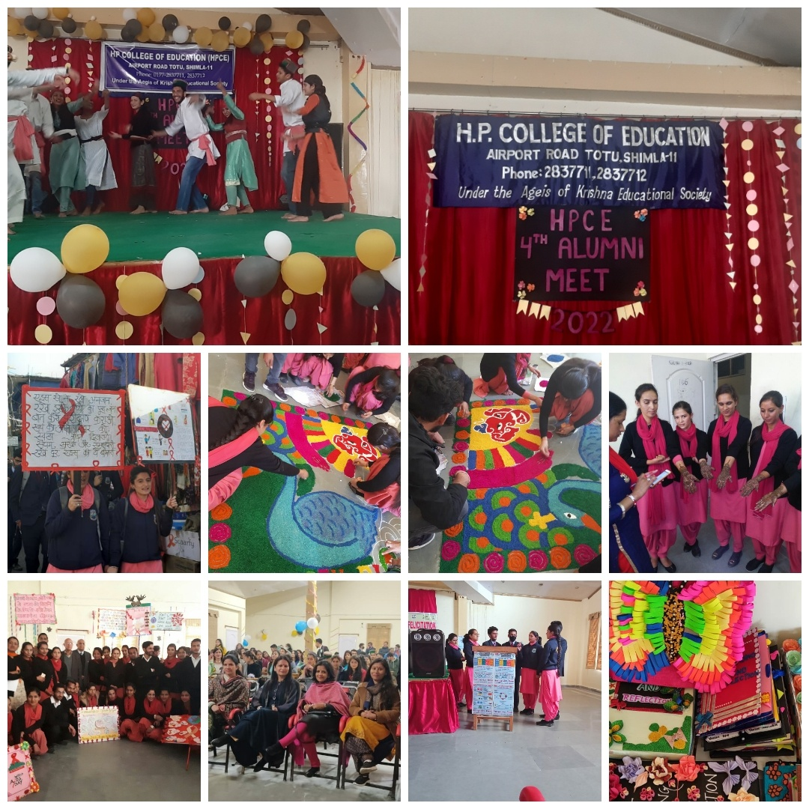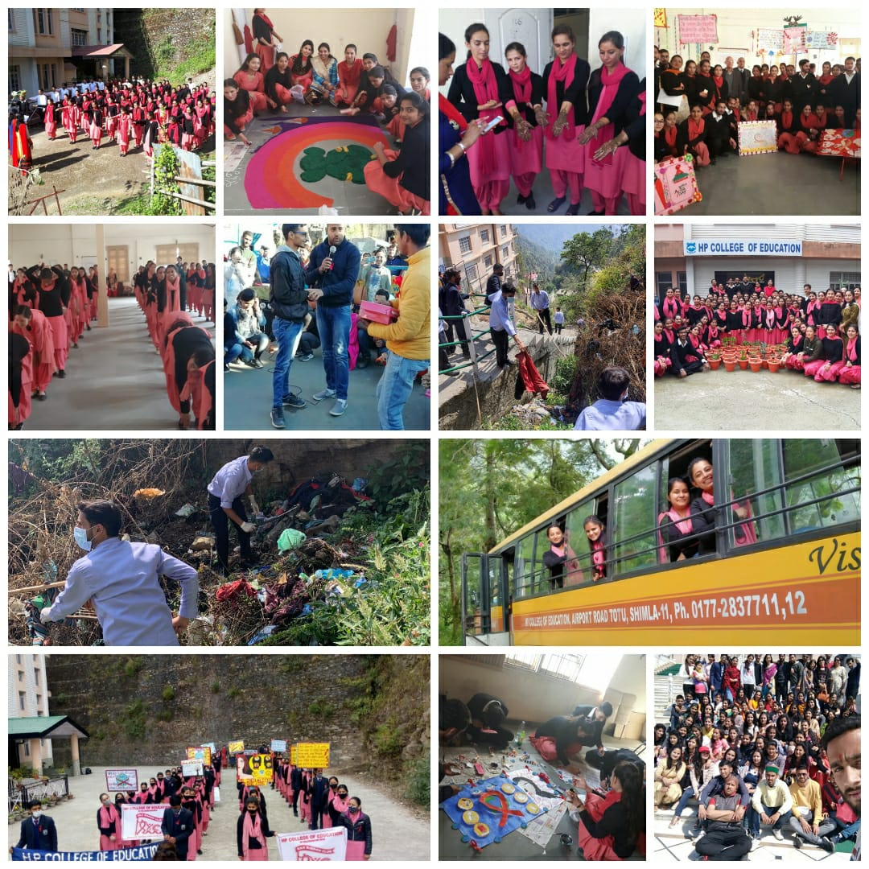

***Achievements***

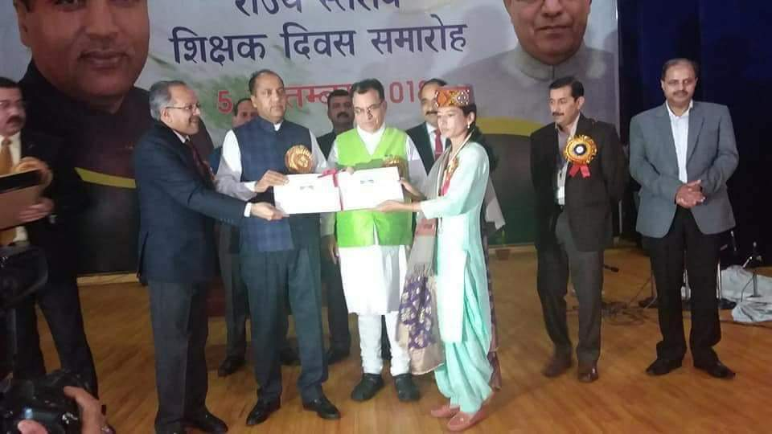  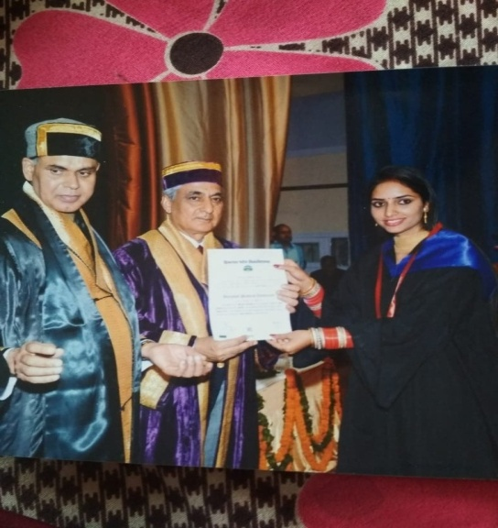

Gold Medalist in Final Examination conducted Received State Award for Best Teacher

By HPU(Session 2014-15)

***Rank Holders in Final Examination Conducted by HPU***

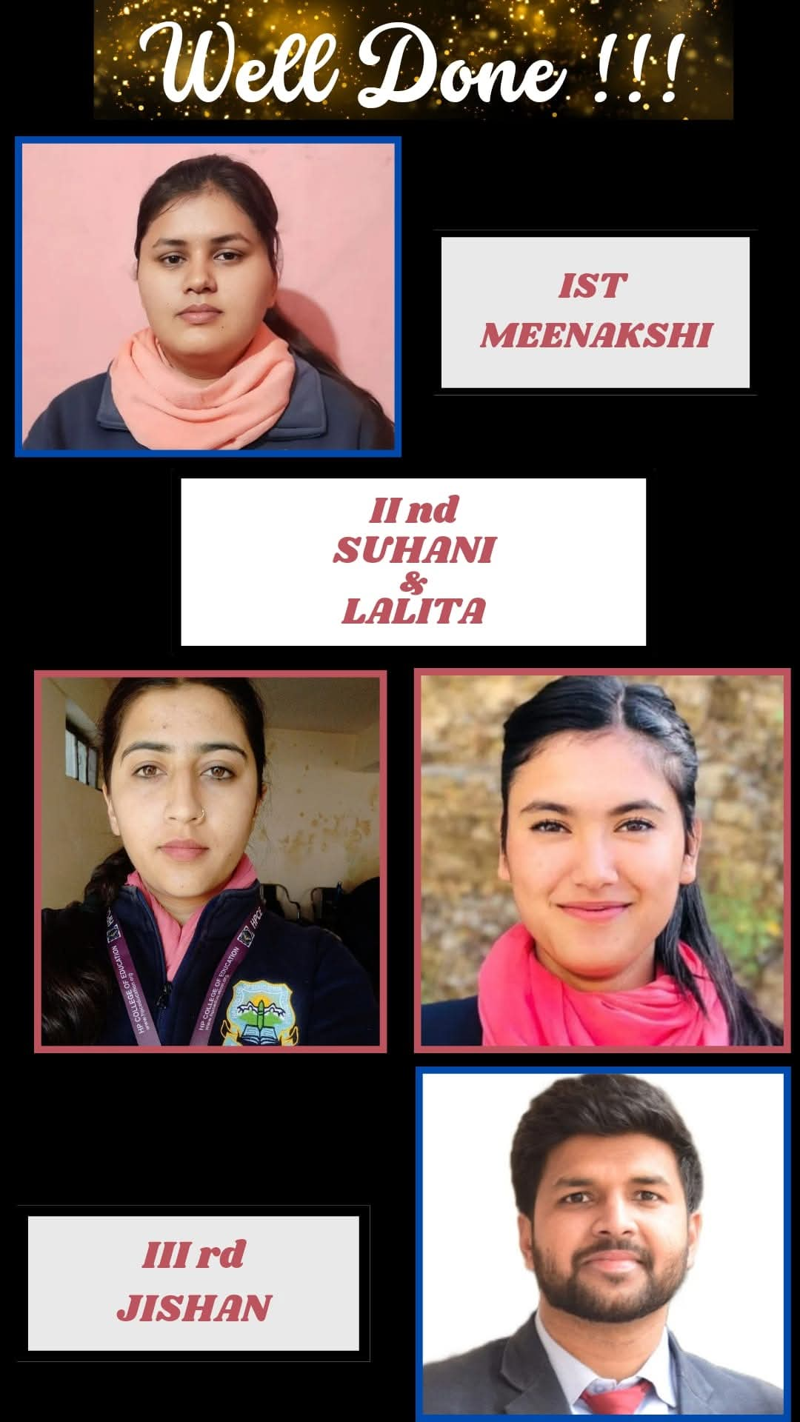

**REGULATORY COMMISSION (HP-PERC)**

MAJITHA HOUSE COMPLEX, SHIMLA-171002(HP)

<Tel:0177-2629665,2629663> Fax: 91-2629664 Email : [secy-perc-hp@nic.in](mailto:secy-perc-hp@nic.in) Website:http:// hp.gov.in/hpperc

**NOTICE**

It is mandatory under the **HIMACHAL PRADESH PRIVATE EDUCATIONAL INSTITUTIONS (REGULATORY COMMISSION) ACT, 2010** that all the Private Higher Educational Institutions including Universities & Colleges in the State shall offer approved courses, make admissions on merit, charge fees as approved by the State Govt. conduct fair examination/evaluation and adhere to the relevant regulatory body norms regarding faculty and infrastructure.

Any **violation of the norms** by the private Educational Institutions **will attract penal provisions** under section 11 of the Act ibid.

For any **grievance/complaints** concerning any academic or administrative lapse(s), such as overcharging of fees, admission in contravention of norms, malpractices in teaching and examinations, and deficiencies in faculty and infrastructure please contact the **Secretary/public Grievance Officer, HP-PERC** at the above address/email along with relevant supporting documents, if any, for taking necessary action.

|  |  |
| --- | --- |
| Helpline No. | 0177-2673664 |
| Email | [secy-perc-hp@nic.in;regulation-perc-hp@nic.in](mailto:secy-perc-hp@nic.in;regulation-perc-hp@nic.in) |
| Tele Fax | 0177-2673663 |

BY ORDER

CHAIRMAN

**HP COLLEGE OF EDUCATION (HPCE )**

**Airport Road, Totu, Shimla 171011**

**ADMISSION/ REGISTRATION FORM for B.Ed.**

Affix passport size photograph

**SESSION 2024 - 26**

**Sr. No.** ----------------

**To be filled in by the candidate in his/her own handwriting (in Capital Letters)**

1. **Name of the Candidate (As in Matriculation Certificate)**

**2. Date of Birth: (dd/mm/yy)**

1. **Nationality**

**4. Sex: M:** **F**:

**5. Aadhar No.**

**6. Father’s Name:**

**6.i Father’s Occupation 6.ii Phone Nos.**

**6.iii Father’s Official Address**

**6.iv Father’s Total Annual Income (Rs.Lacs)**

**7. Mother’s Name:**

**7.i Mother’s Occupation 7.ii Phone Nos.**

**7. iii Mother’s Official Address**

**7. iv. Mother’s Total Annual Income (Rs. Lacs)**  .

**8. Permanent Address:**

**Tel. Nos.: E-mail ID: _______________**

**Mobile:**

**9. Address for Correspondence:**

**10.** **State of Domicile:**

**11.** **Category under which admission is sought:**

**General SC ST OBC Others**

**12. H.P. University Registration Number**

**13. Teaching Subjects:** (i)

(ii) ----------------------------------------------------------------------

**14.**  **Educational Qualifications:**

|  |  |  |  |  |  |
| --- | --- | --- | --- | --- | --- |
| **Examination** | **Name of University /Board** | **Year of Passing** | **Subjects** | **Marks Obtained / Max. Marks** | **Percentage /Division** |
| **Matric** |  |  |  |  |  |
| **10+2** |  |  |  |  |  |
| **Graduation**  **(Specify)………...** |  |  |  |  |  |
| **M.A/M.Sc.** |  |  |  |  |  |
| **Any other** |  |  |  |  |  |

**15**. Have you ever been disqualified by any Board/ University. If so, give details………………………………………………………………………………

**Undertaking by the Candidate:**

I, ……………………..Son/Daughter of Sh. ………………hereby declare that the entries made above by me in the form are correct to the best of my knowledge. I am conscious that if any of the entries are found to be incorrect my admission is liable to be cancelled.

1. I have carefully read the handbook of information and undertake to abide by the rules of the College/university.
2. I hold myself responsible for the payment of fees and other dues on the dates according to the schedule of the College.
3. I am aware about the rules and regulations regarding Ragging and the Discipline of the College/H.P. University and agree to abide by the punishment meted out to me in case the later I am found guilty of ragging and/or abetting ragging.
4. I declare that I will have no claim against the order of the rustication/expulsion from the College / University.

Signature of the Applicant

**Undertaking By the Parents/Guardian:**

1. I am aware about the rules and regulations regarding Ragging and the Discipline of the College/H.P. University and agree to abide by the punishment meted out to my ward in case the later he/her is found guilty of ragging and/or abetting ragging.
2. I declare that I will have no claim against the order of the rustication/expulsion of my ward from the College / University. Signature of the Parent/Guardian

(FOR OFFICE USE ONLY)

Category………………Roll No………..Amount Received Rs. ………………Receipt No & Date………………………..

Certified that all documents have been checked and found in order / not in order/ following deficiency pointed out:-

Superintendent (Admission)

**CHECK LIST ENCLOSURES**

**(Please √)**

**For Candidate For Office Use Remarks**

(1) Matriculation (10th) Certificate

(2) 10+2 (Sr.Sec. Certificate)

(3) Graduation Certificate

(4) Character Certificate

(5) University Registration No. /

Migration /Transfer Certificate

(Original)

(6) Passport Size Photographs

(2 Nos) Spare

(7) Bonafide Certificate

(8) Relevant Certificate

(For Reservation)

(9) Aadhar Number

(10) Other Document, if any

***Note: Please attach attested photocopies of all the certificates/documents***

(Signature of the Candidate)

Recommendations of the Admission/ Counseling/ Interview Committee

Admission Recommended/Rejected

Co-ordinator Admission Committee Principal / Registrar

**HP COLLEGE OF EDUCATION (HPCE )**

**Airport Road, Totu, Shimla 171011**

**HOSTEL REGISTRATION FORM**

Affix passport size photograph

**SESSION 2023-25**

**Sr. No.** ----------------

**To be filled in by the candidate in his/her own handwriting (in Capital Letters)**

1. **Name of the Candidate (As in Matriculation Certificate)**

**2. Date of Birth: (dd/mm/yy)**

1. **Nationality**

**4. Sex: M:** **F**:

**5. Aadhar No.**

**6. Father’s Name:**

**7. Mother’s Name:**

**8. Permanent Address:**

**Tel. Nos.: E-mail ID: _______________**

**Mobile:**

**9. Address for Correspondence:**

**10. Name and Address of Local Guardian and their Relationship with the candidate:**

**11. Relation :**

**12. Mobile No.**

**14.**  **Educational Qualifications:**

|  |  |  |  |  |  |
| --- | --- | --- | --- | --- | --- |
| **Examination** | **Name of University /Board** | **Year of Passing** | **Subjects** | **Marks Obtained / Max. Marks** | **Percentage /Division** |
| **Matric** |  |  |  |  |  |
| **10+2** |  |  |  |  |  |
| **Graduation**  **(Specify)………...** |  |  |  |  |  |
| **M.A/M.Sc.** |  |  |  |  |  |
| **Any other** |  |  |  |  |  |

**Hostel Rules:**

I. Students will be required to apply for hostel at the time of admission.

II. The boarders will not be allowed to stay out after 7 P.M. in summer and 6 P.M. in Winter.

III. The boarders will have to get leave sanctioned from the Warden or Principal.

IV. No outsider will be allowed to stay in hostel premises.

V. Boarders will be required to pay hostel dues in advance.

VI. After university examination the boarder will have to vacate the rooms.

VII. Boarders should not keep cash, jewelry or other valuable things in their rooms.

The responsibility of safety of the belongings will be entirely of the boarder.

VIII. Every boarder shall be responsible for the safety of furniture / other articles given to her.

IX. Acts of indiscipline and misbehavior in the hostel shall be severely dealt with as per

College rules.

X. Use of any kind of intoxicant is strictly prohibited.

XI. Before leaving the hostel, every boarder shall obtain clearance from the warden and

Personally handover the charges of the rooms to the Warden.

XII. A boarder may be expelled from the hostel if she stays away from the hostel without the permission of the Principal / Warden.

XIII. Shouting, hooting and violence that is likely to cause disturbance to others is strictly

prohibited.

XIV. Any kind of illness should be immediately reported to the Warden.

XV. The visit to local guardian shall be restricted to those whose names appear in the list of local guardian furnished at the time of admission.

**Declaration by the Candidate:**

I hereby declare that the particulars given above are correct up to my knowledge and I have read all the rules and regulations of the Hostel that are enforced time to time.

Signature of the Applicant

(FOR OFFICE USE ONLY)

Roll No……………………………….

Amount Received Rs. …………………………….Receipt No & Date………………………..

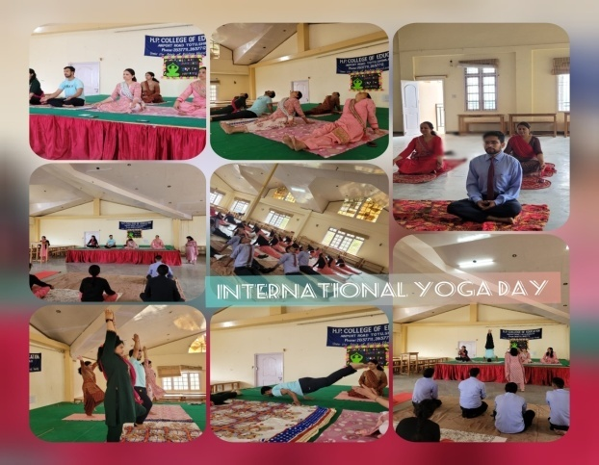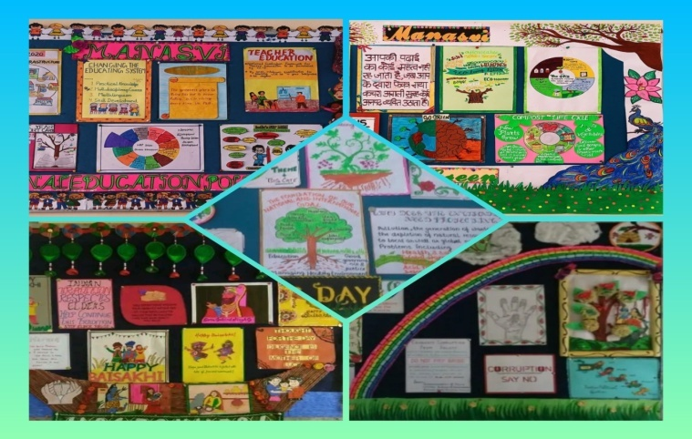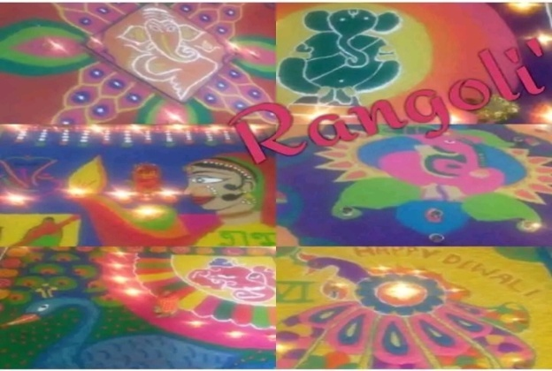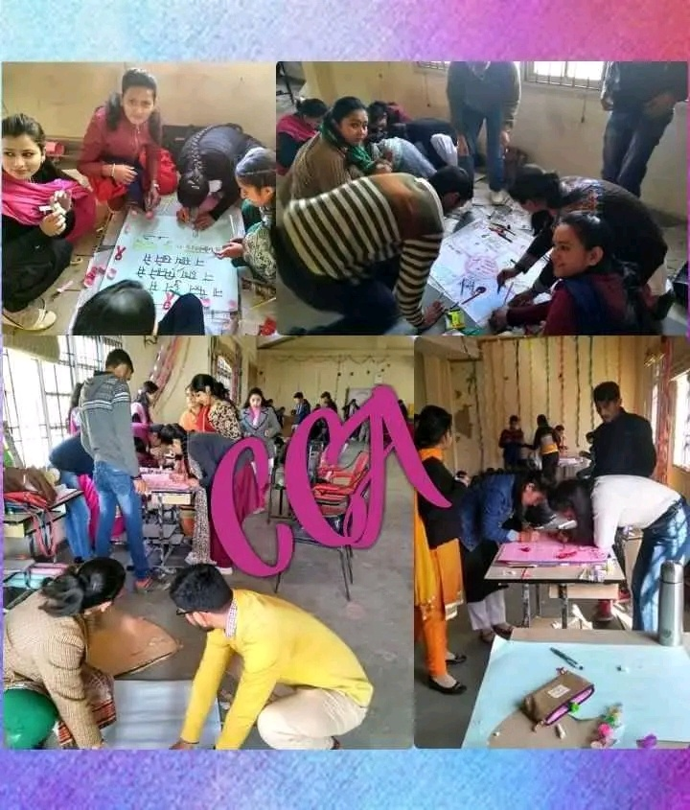

CCA

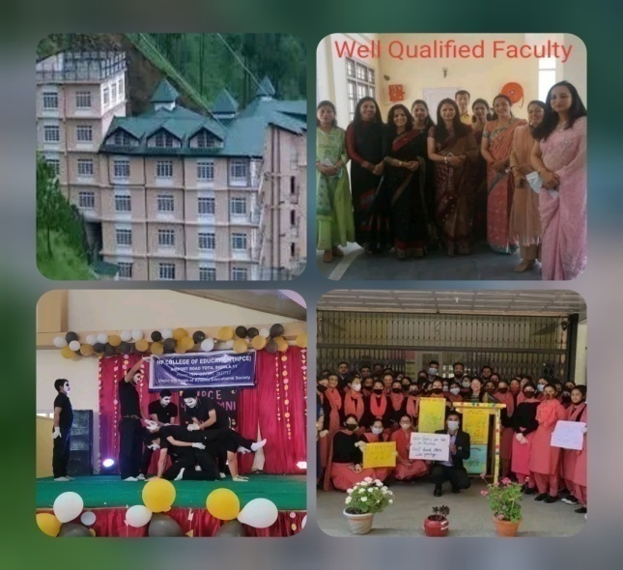 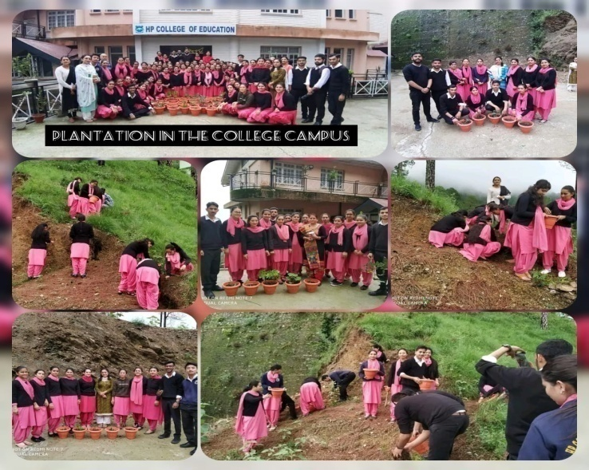

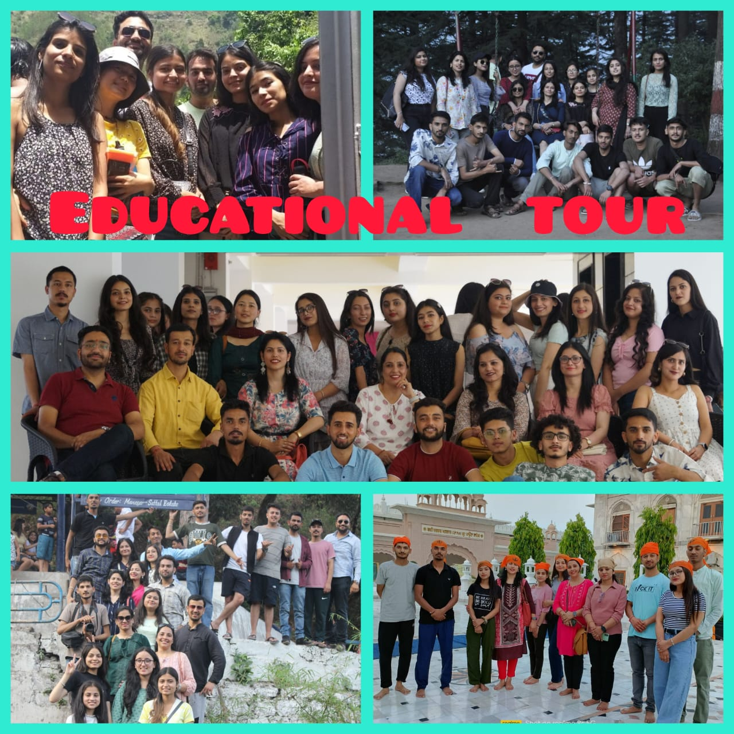

***NOTICE BOARD WORK***



